MatLab Assignment 3

eng1_gs = pic2grayscale(eng1);
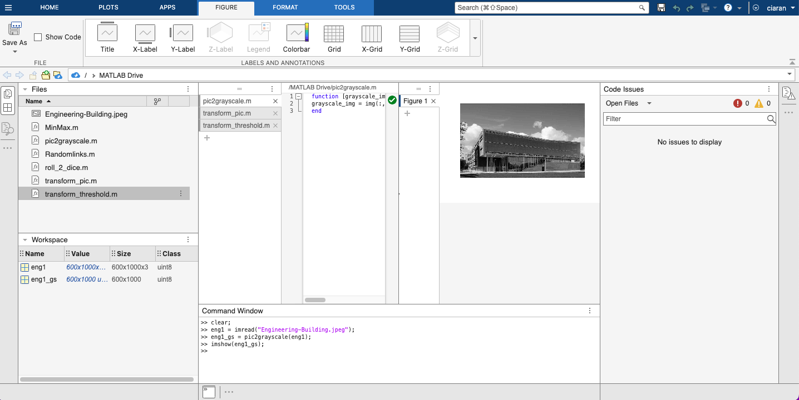

eng1_gs_inv = transform_pic(eng1_gs);
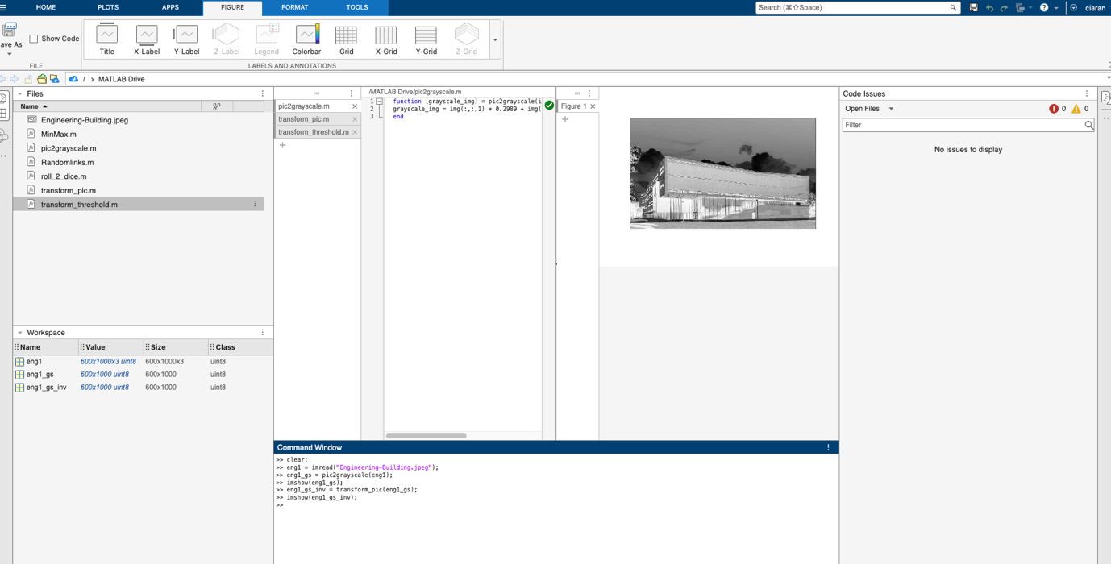

eng1_gs_bin_50 = transform_threshold(eng1_gs,50);
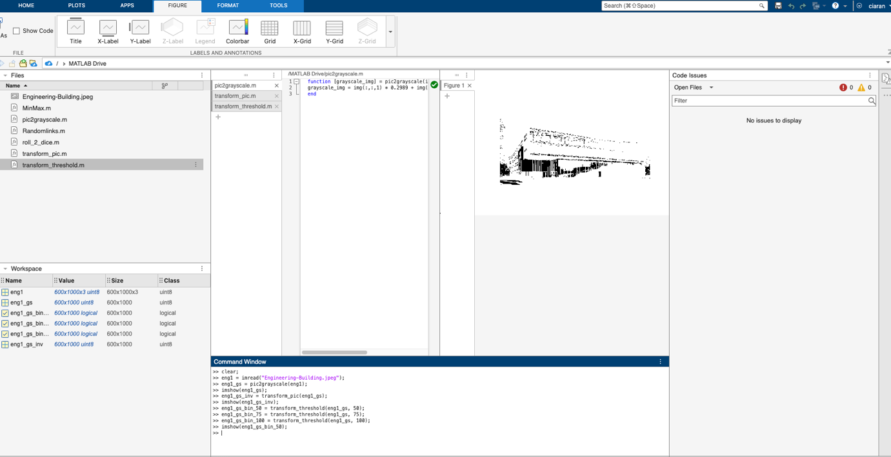

eng1_gs_bin_75 = transform_threshold(eng1_gs,75);
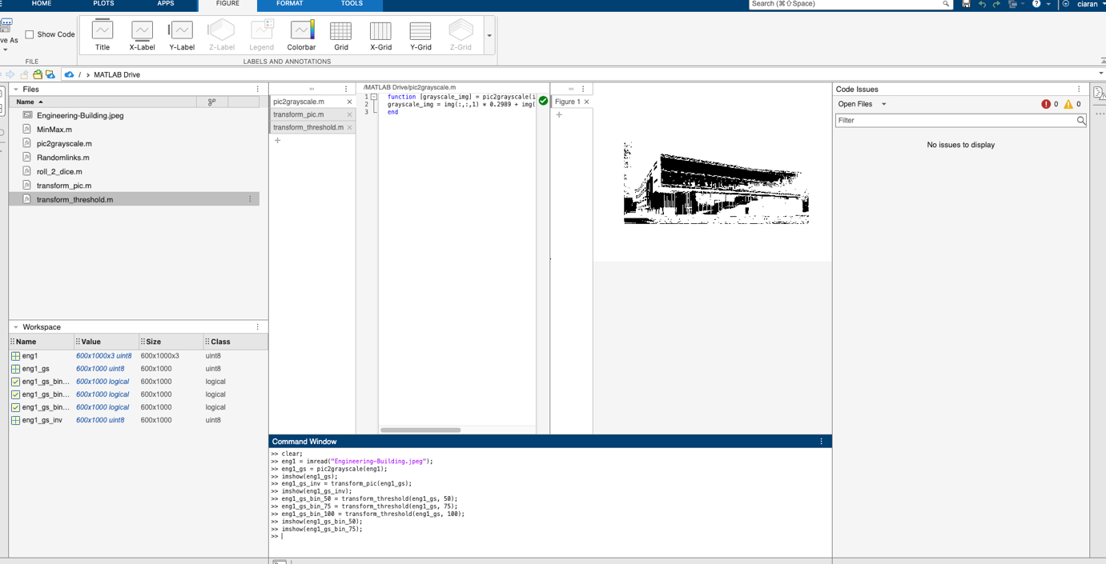

eng1_gs_bin_100 = transform_threshold(eng1_gs,100);
